**HR Employees Recruitment Prediction Dashboard (Humanlytics)**

Technical Report

Muhammad Arslan  
 School of Computing and Engineering  
 University of Missouri - Kansas City  
 Kansas City, Missouri  
manbb@umsystem.edu

Dallas Diaz  
 School of Computing and Engineering  
 University of Missouri - Kansas City  
 Kansas City, Missouri  
ddmnh@umsystem.edu

Muhammad Tayyab  
 School of Computing and Engineering  
 University of Missouri - Kansas City  
 Kansas City, Missouri  
mt56w@umsystem.edu

**ABSTRACT**

This innovative initiative aims to design and implement a user-friendly dashboard tailored for HR professionals and recruiters, offering real-time insights and analytics to optimize recruitment processes. The project encompasses requirements gathering, dashboard design, development, analytics integration, thorough testing, documentation, and deployment. By consolidating data from various sources, the dashboard aims to provide comprehensive visualizations of key HR metrics, fostering data-driven decision-making. The project's objectives include enhancing user experience, promoting internal mobility through an internal job marketplace, and ensuring data security and regulatory compliance. With a dedicated team of developers, designers, and data analysts, the project is set to be completed within a four-month timeline, adhering to predefined milestones and deliverables. Governance mechanisms, communication strategies, risk identification, and mitigation plans are integral components of the project management framework. Upon successful completion, the HR dashboard will be formally closed, having met acceptance criteria and provided the necessary training and documentation for seamless integration into HR operations**.**

**1- Introduction**

In response to the growing need for more efficient HR practices, our HR Dashboard Development project aims to introduce a user-friendly dashboard tailored for HR professionals and recruiters. This initiative comes at a crucial time when organizations seek innovative solutions to enhance their recruitment processes. The dashboard, a culmination of insights from employee engagement, retention rates, performance evaluations, diversity statistics, and more, is poised to redefine how organizations analyze and interpret crucial HR data. By centralizing HR metrics, our platform promises a holistic view of an organization's workforce dynamics. The project's realistic objectives include creating an interface that aligns with user needs, consolidating data from multiple sources, implementing analytics for recruitment KPIs, fostering internal mobility through an internal job marketplace, and ensuring data security and regulatory compliance. With a dedicated team of developers, designers, and data analysts, we are confident that this project will provide actionable insights and contribute significantly to data-driven decision-making in HR operations.

**2- Triangle Model**

Our HR Dashboard Development project adopts a robust triangular model, integrating three key components for a comprehensive solution. For the frontend, we leverage a modern and user-friendly interface, utilizing technologies such as VS Code and Streamlit to ensure an intuitive user experience. The backend is powered by Python, facilitating efficient data processing and management. Firebase serves as our database, offering a secure and scalable storage solution for HR-related data. This choice aligns with our commitment to data security and real-time accessibility. At the forefront of our project is the AI model, where we harness the power of GPT-3.5 for intelligent data analysis and interpretation. The successful connection of these three components, each playing a vital role in the project architecture. 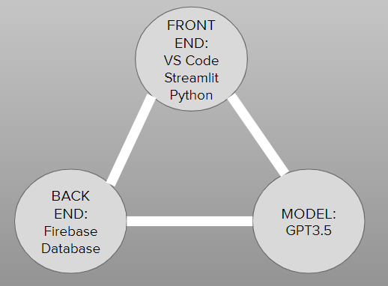

*Figure 1.*

In this figure1 it shows all the components we are using.

**3. DATASET**

The acquisition of company datasets, comprising both structured and unstructured formats, stands as a pragmatic cornerstone in the development of our HR Dashboard. The structured datasets, containing detailed information such as company names, locations, employee counts, and essential HR metrics, provide a solid foundation for our analytics and visualizations. These datasets, collected from diverse industries, reflect the realistic intricacies of workforce data in various organizational settings. Simultaneously, unstructured datasets, capturing textual nuances related to HR activities, present an opportunity for our AI model, GPT-3.5, to clean valuable insights. The realistic inclusion of a range of companies, each with its unique characteristics and challenges, ensures that our dashboard is tailored to real-world scenarios, accommodating the complexities and diversities inherent in HR operations.

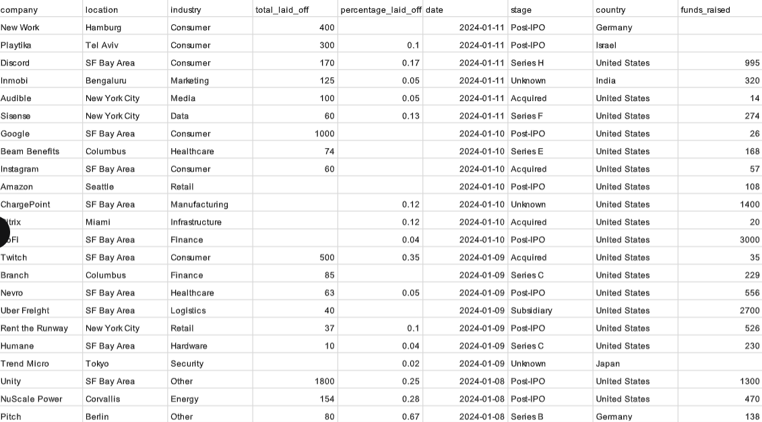

*Figure 2*

In figure 2 it is showing the raw data of the layoff.

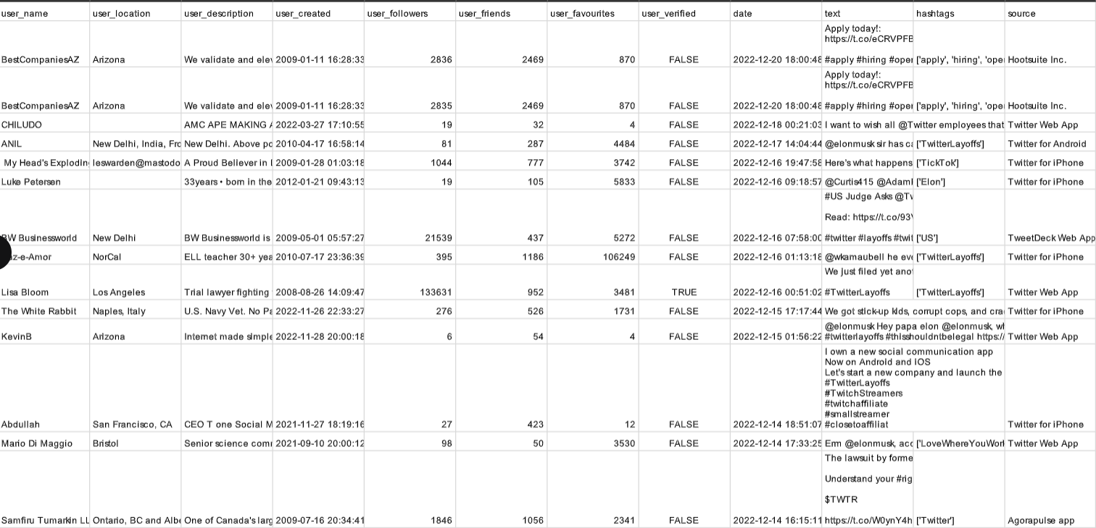

*Figure 3*

In figure 3 it is showing the raw data we have collected from the employees tweets.

**3.1 DATA PRE-PROCESSING**

For better visualization and analysis we extract some information from the data set and also rename some columns we have performed these steps shown below.

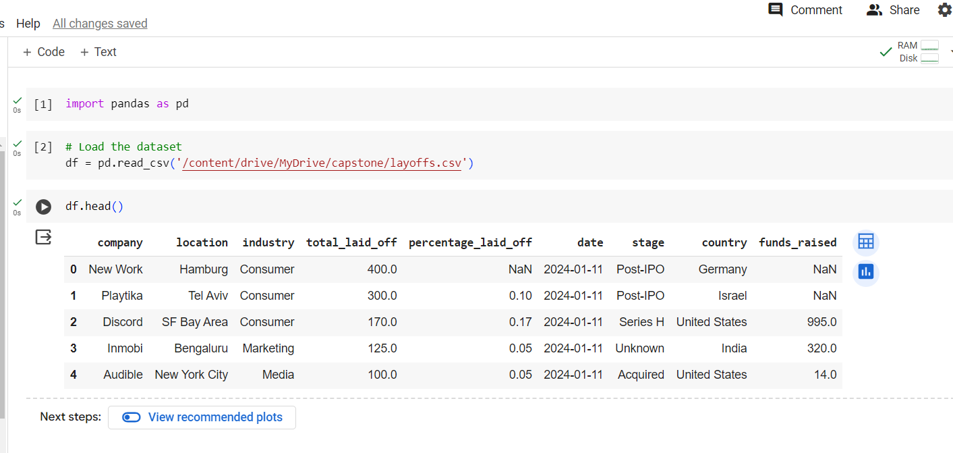

*Figure 4*

In figure 4 we perform the Column Removal. This approach simplifies the dataset by removing attributes that are irrelevant to the investigation, boosting model performance, and increasing interpretability.

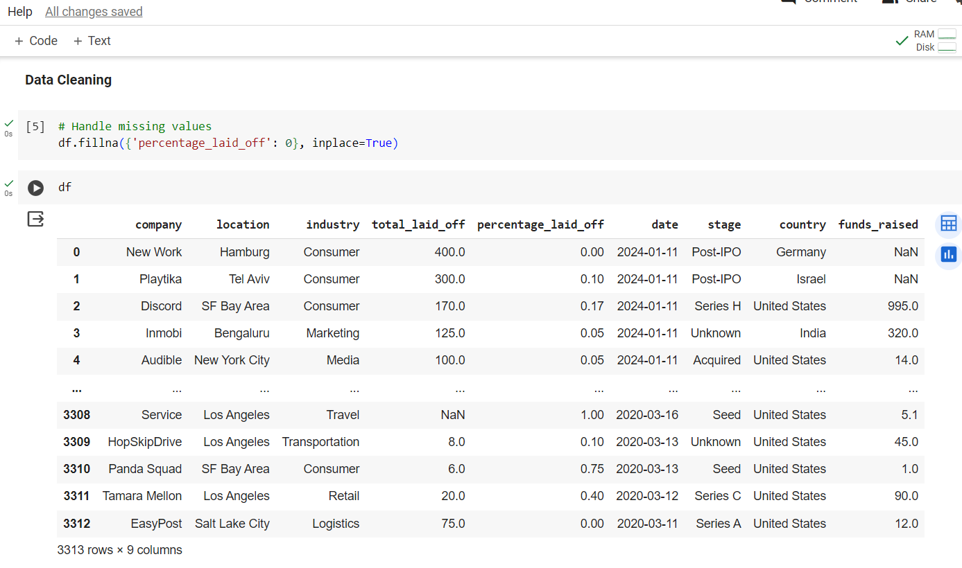

*Figure 5*

In figure 5 we perform the Column renaming. This clarifies the dataset and assists users in understanding the purpose and substance of each attribute.

In figure 6 we are dealing with *NaN* or *null* values in the dataset. To maintain data quality and analytical accuracy, common procedures include imputation (replacing missing values with estimates), eliminating rows or columns with missing values, or specific treatment based on the context.

*Figure 6*

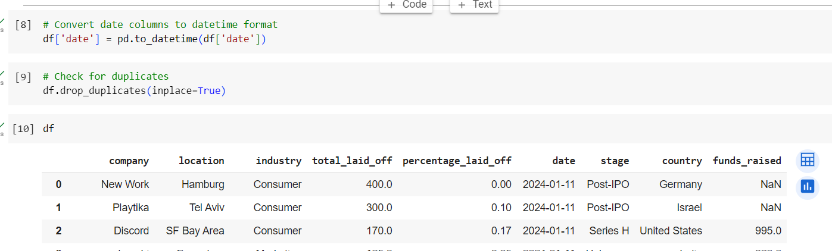

Data Type Identification: Recognizing the data type (e.g., integer, float, string) of each column is critical for selecting appropriate data transformation techniques, dealing with categorical variables, and ensuring compatibility with analysis or modeling algorithms as shown in figure 6.

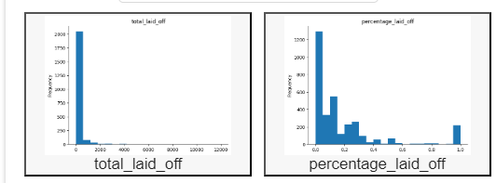

*Figure 7*

**3.2 Data Analysis:**

In our HR Dashboard, we've implemented two insightful graphs to provide a comprehensive view of workforce dynamics. The first graph elegantly illustrates the percentage of layoffs, offering a visual representation of the proportion of employees affected. This metric is crucial for understanding the relative impact on different departments or organizational levels. The second graph, focusing on the total number of layoffs, offers a tangible figure, providing a quantitative perspective on the extent of workforce changes. Together, these graphs empower HR professionals with valuable insights into workforce restructuring, facilitating strategic decision-making and proactive management of organizational changes.

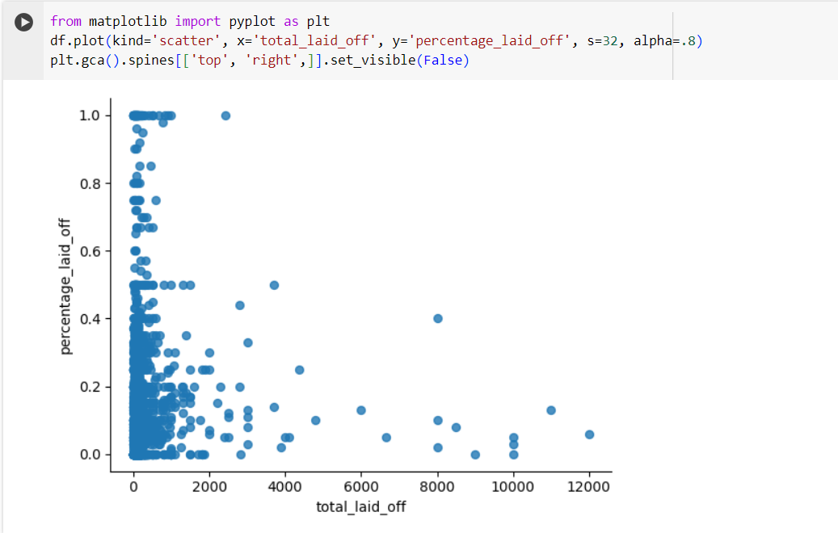

*Figure 8*

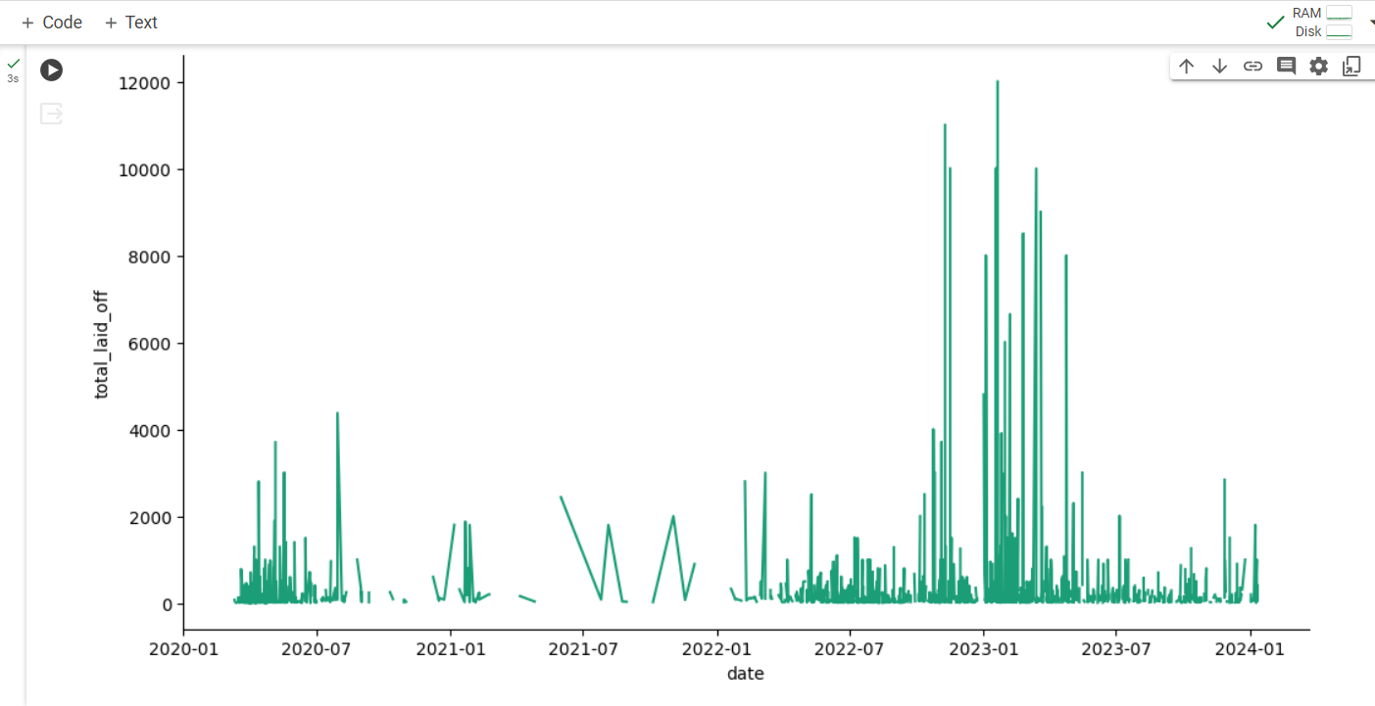

*Figure 9*

In figure 9 the graph depicting the total layoffs from 2020 to 2024 serves as a dynamic temporal visualization, offering a chronological overview of workforce changes over the specified period. This graph provides HR professionals with a comprehensive historical perspective, enabling them to identify trends, patterns, and potential correlations with external factors such as economic fluctuations or organizational shifts. The plotted data facilitates the analysis of long-term workforce dynamics, helping stakeholders make informed decisions based on historical context. This graphical representation proves instrumental in understanding the trajectory of workforce changes, supporting strategic planning, and fostering a proactive approach to human resource management.A pivotal moment in the pandemic, as numerous U.S. school districts initiated the transition to online learning. This shift in educational delivery transformed the daily routines and mobility patterns of students, parents, and educators.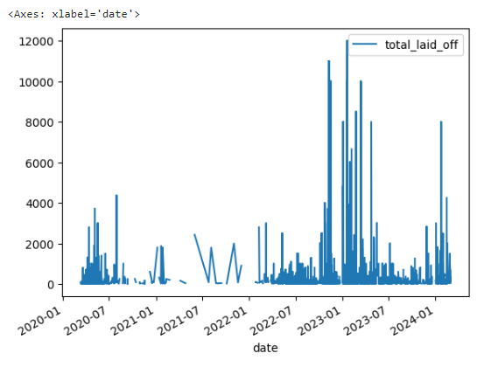*Figure10*

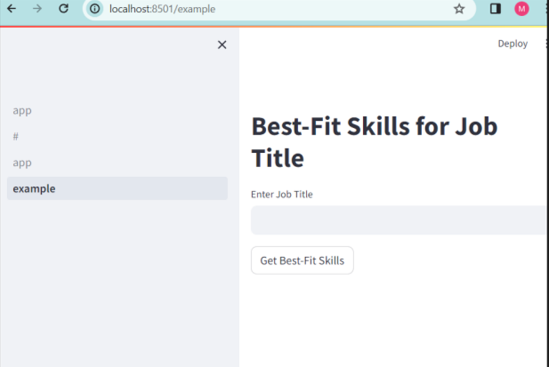

*Figure 11*

The integration of a user-friendly front-end feature, where applicants input their skills to receive tailored job recommendations, marks a significant advancement in our HR Dashboard. This innovative interface not only streamlines the job application process but also enhances the user experience by providing personalized and relevant job matches. Applicants can enter their skill sets, and the system, powered by advanced algorithms, swiftly matches their qualifications with available job opportunities. This dynamic front-end functionality not only empowers applicants to find roles that align with their expertise but also facilitates a more efficient and targeted recruitment process for HR professionals. This user-centric approach reinforces the dashboard's commitment to improving accessibility and engagement, ultimately fostering a more seamless connection between job seekers and potential employers.

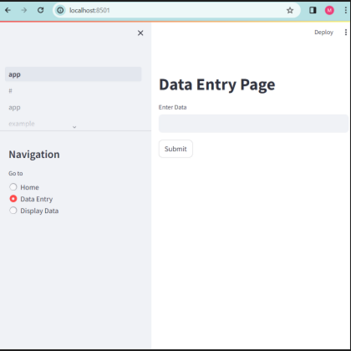

*Figure12*

In figure 12 it showed the incorporation of a data entry box on the front end, seamlessly connected to our backend database using Firebase, enhances the functionality and versatility of our HR Dashboard. This feature allows for the easy and efficient input of new data directly from the user interface, eliminating the need for complex data entry processes. The entered data, encompassing various HR metrics and information, is securely stored in our Firebase backend, ensuring real-time accessibility and centralized management.

**3.3-Model-Implementation:**

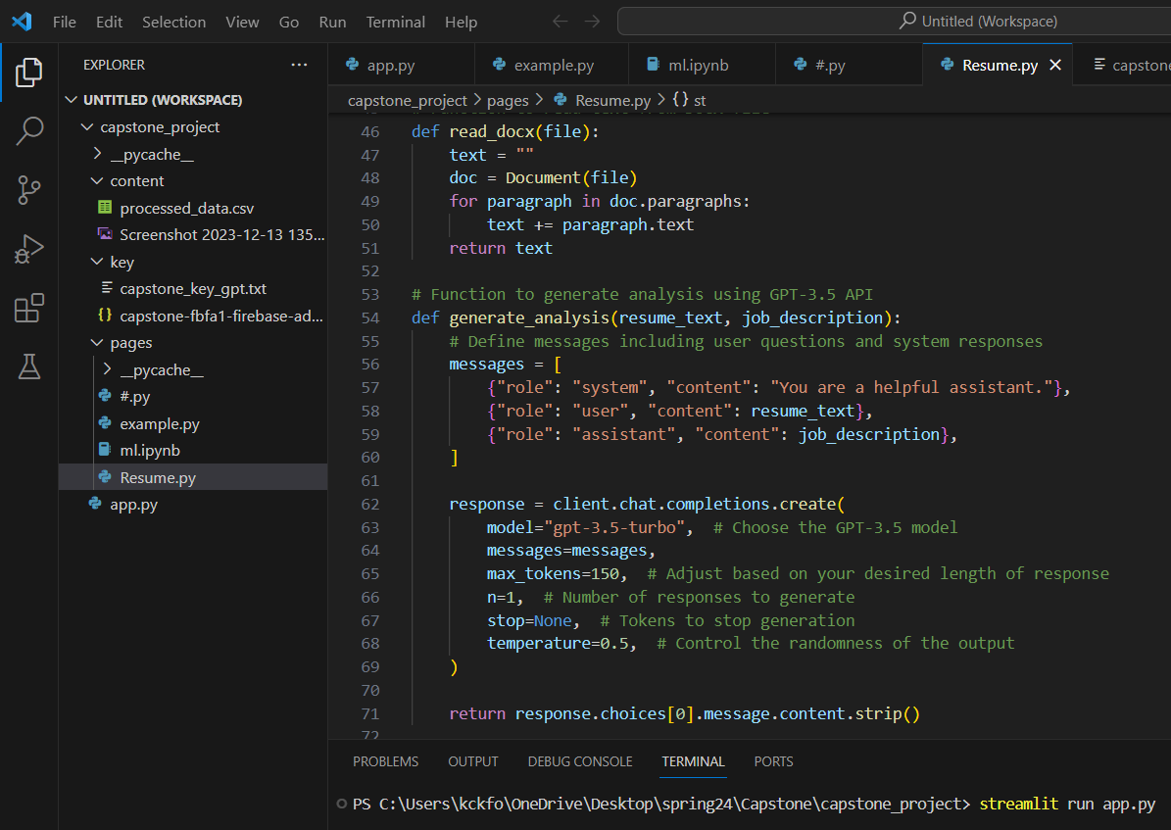

*Figure 13*

In figure 13 the function uses the GPT-3.5 API to generate textual analyses depending on user input. It allows you to customize settings like response length, amount of responses, and randomization control. Furthermore, it contains facilities for defining user inquiries and system responses, allowing flexibility in generating specialized analysis.

*Figure14*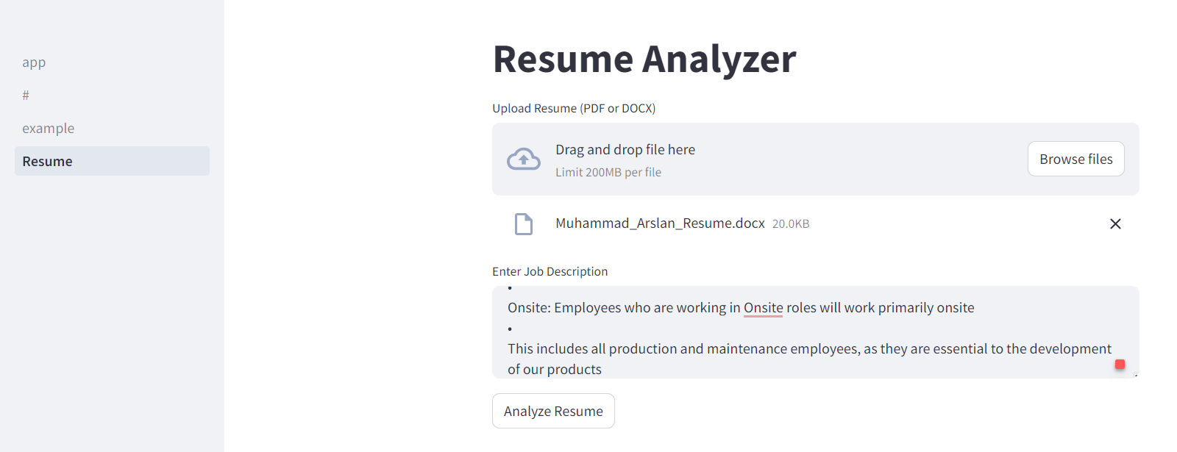

In figure 14 the integration of a resume analysis function in our HR Dashboard significantly improves user experience and recruitment efficiency. By allowing applicants to submit their resumes, our system uses sophisticated algorithms to extract relevant skills and qualifications. This research offers specific employment recommendations based on each applicant's expertise and career goals. This unique feature not only speeds the application process, but also provides HR managers with vital information about candidate profiles. Our dashboard enables a more targeted recruitment process by utilizing AI-driven resume analysis, matching individuals with opportunities that best suit their strengths.

*Figure15*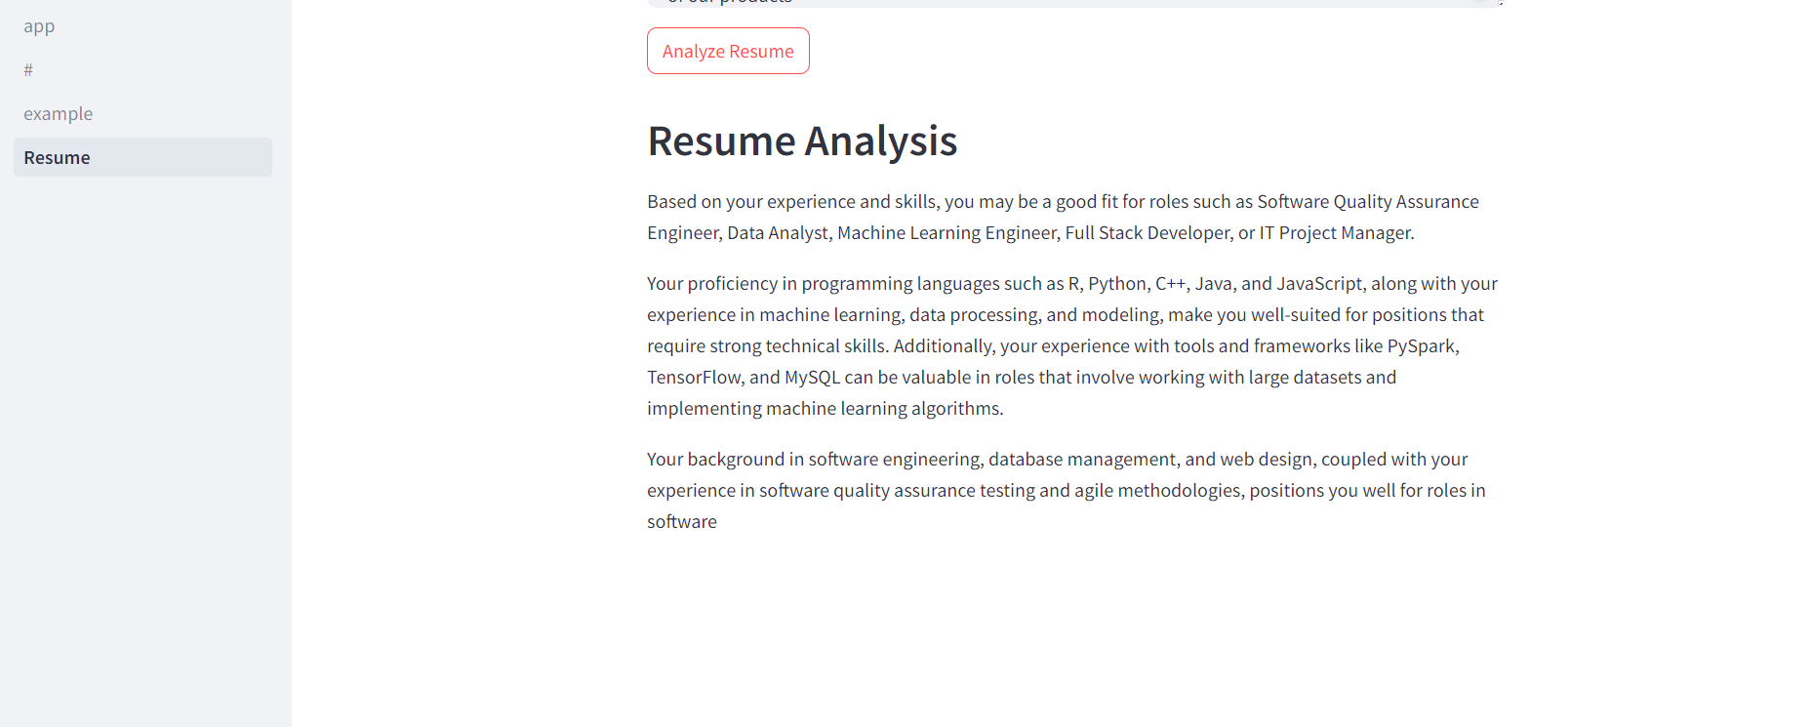

In figure 15 the GPT-3.5 model offers a significant leap in candidate evaluation. This tool provides users with comprehensive insights on their resumes, including relevant talents, experiences, and qualifications found using powerful natural language processing. Our system uses the capabilities of GPT-3.5 to provide thorough analysis and comments on resumes, allowing users to better understand their strengths and areas for improvement.

In figure 16 The inclusion of the Firebase data importer functionality in our HR Dashboard improves data management and accessibility for HR professionals. This feature allows users to simply enter additional address or skill data straight into our backend Firebase database via a user-friendly interface. This automated approach eliminates the need for manual data entry and guarantees that the database is updated in real time. We ensure data integrity while allowing easy integration with the dashboard's analytics and visualization features by utilizing Firebase's scalable and secure storage solution.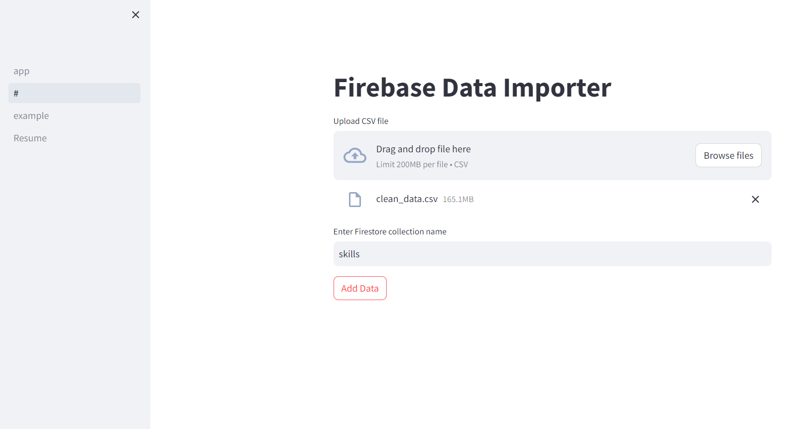

*Figure 16*

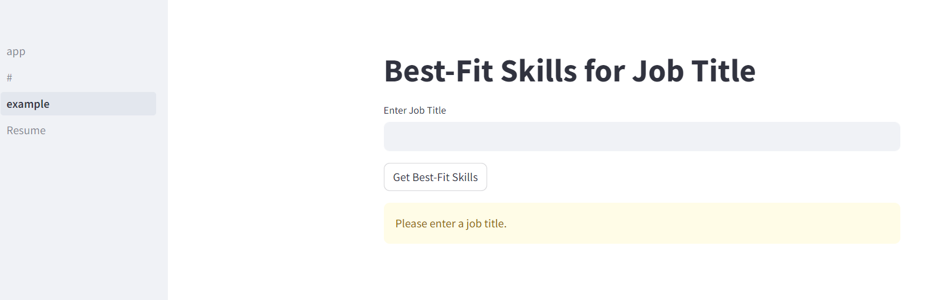

*Figure 17*

In figure 17 The addition of a "Best Skill Fits" feature to our HR Dashboard's frontend greatly improves the user experience and job search process. This function allows users to enter their desired job search parameters, such as job title or industry, and our system uses complex algorithms to identify the most appropriate talents for those opportunities. The recognized abilities are then displayed in a user-friendly interface, giving candidates important information about the main qualifications required for their preferred roles. This tool not only streamlines the job search process, but it also allows individuals to efficiently adjust their skill sets to meet industry demands. Finally, the "Best Skill Fits" tool demonstrates our dedication to offering actionable information and personalized suggestions to help people find jobs and grow their careers.

*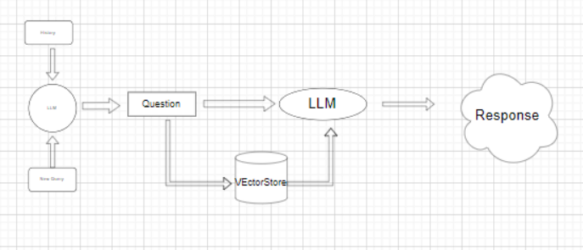Figure18*

The inclusion of a conceptual diagram displaying the LLM (Long-Short Term Memory) model utilized in our system demonstrates the complex process of handling incoming requests and generating responses. This model serves as the foundation for our system's natural language processing capabilities, allowing it to understand and interpret user queries effectively. Incoming requests, such as job search parameters or resume uploads, are handled by the LLM model, which evaluates the context and extracts pertinent data. As a result, the model produces accurate and contextually appropriate responses, ensuring a smooth connection between people and the system. This conceptual diagram demonstrates the sophisticated technology behind our HR Dashboard, demonstrating our dedication to employing advanced AI models to enhance the user experience and give significant insights in the field of human resources.

**Future work**

Using the LLM (Long-Short Term Memory) model allows for further analysis and enhancements within our HR Dashboard. The LLM model's capacity to grasp and process natural language enables enhanced sentiment analysis of employee input, allowing HR executives to assess staff happiness and highlight areas for improvement.

**ACKNOWLEDGMENTS**

We would like to thank Professor Yugyung Lee, Ph.D., for teaching us the subject that serves as the foundation for understanding and working on this topic, as well as for assisting us by providing useful input at various points to help us enhance our work. We would also like to thank other students in our class for contributing ideas that provided us with a different viewpoint

**REFERENCES**

[1] <https://streamlit.io/>

[2] <https://colab.research.google.com/>

[3] <https://platform.openai.com/docs/models>

[4]<https://spark.apache.org/docs/latest/api/python/index.html>

[5] <https://jupyter.org/>